DevOps Assignment Report

Practice Assignment on Testing, Linux and Servers

Name: Dipak Dave

Introduction
This assignment focuses on implementing core DevOps practices including system monitoring, user management, and automated backup configuration. The objective was to create a secure, efficient, and well-monitored development environment for two developers, Sarah and Mike.

Task 1: System Monitoring Setup

Objective
To monitor system performance, identify resource usage, and maintain logs for analysis.

Implementation
- Installed htop for real-time monitoring of CPU, memory, and processes.
- Used df -h to check disk usage.
- Used du -sh to analyze directory size.
- Used ps aux to identify resource-intensive processes.

Commands Used
htop
df -h
du -sh /home/*
ps aux --sort=-%cpu | head

Logging
System metrics were stored in:
/var/log/system_monitor.log

Outcome
- Successfully monitored system performance
- Identified high CPU processes
- Maintained logs for future analysis

Task 2: User Management and Access Control

Objective
To create secure user environments for Sarah and Mike.

Implementation

User Creation
sudo useradd sarah
sudo useradd mike

Workspace Setup
/home/sarah/workspace
/home/mike/workspace

Permissions
chmod 700 /home/sarah
chmod 700 /home/mike
- Ensured only respective users can access their directories

Password Policy
sudo chage -M 30 sarah
sudo chage -M 30 mike
- Password expiry set to 30 days

Outcome
- Secure user access implemented
- Isolated working environments created
- Password policies enforced

Task 3: Backup Configuration

Objective
To automate backups for Apache and Nginx servers.

Apache Backup

Issue Faced
Initially encountered error due to incorrect path:
/etc/httpd (not available in Ubuntu)

Fix Applied
Corrected path:
/etc/apache2/
/var/www/html/

Script
#!/bin/bash

DATE=$(date +%F)

tar -czvf /backups/apache_backup_$DATE.tar.gz /etc/apache2/ /var/www/html/

echo "Backup Created on $DATE" >> /backups/apache_backup.log

tar -tzf /backups/apache_backup_$DATE.tar.gz >> /backups/apache_backup.log

Nginx Backup

Script
#!/bin/bash

DATE=$(date +%F)

tar -czvf /backups/nginx_backup_$DATE.tar.gz /etc/nginx/ /usr/share/nginx/html/

echo "Backup Created on $DATE" >> /backups/nginx_backup.log

tar -tzf /backups/nginx_backup_$DATE.tar.gz >> /backups/nginx_backup.log

Cron Job Setup
0 0 * * 2 /root/assignment/apache_backup.sh
0 0 * * 2 /root/assignment/nginx_backup.sh
- Scheduled every Tuesday at 12:00 AM

Backup Verification
ls /backups
tar -tzf /backups/apache_backup_YYYY-MM-DD.tar.gz

Outcome
- Backup files created successfully
- Verified backup integrity
- Automated scheduling implemented

Challenges Faced
- Incorrect Apache path (/etc/httpd)
  - Fixed by using /etc/apache2
- Cron command error (cronetab)
  - Corrected to crontab
- GitHub push issue (SSH error)
  - Resolved by switching to HTTPS

Conclusion
Successfully implemented:
- System Monitoring
- Secure User Management
- Automated Backup System
This setup ensures a secure, scalable, and production-ready environment following DevOps best practices.

Screenshots
(Attach below)
- System Monitoring (htop)
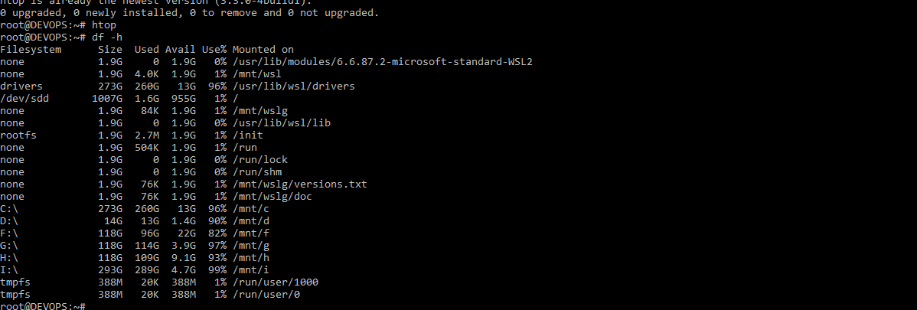
- Disk Usage (df -h)
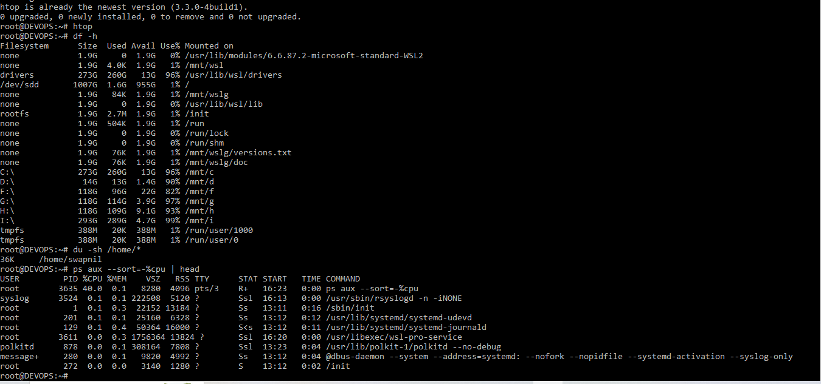
- Directory Usage (du -sh)

- User Creation
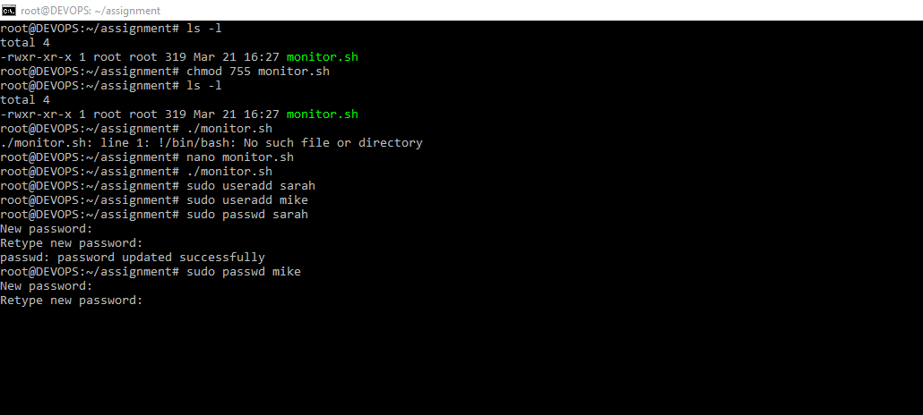
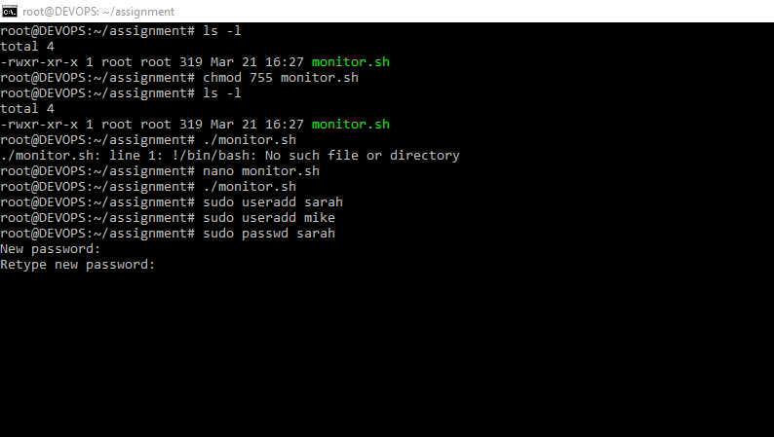
- Permissions
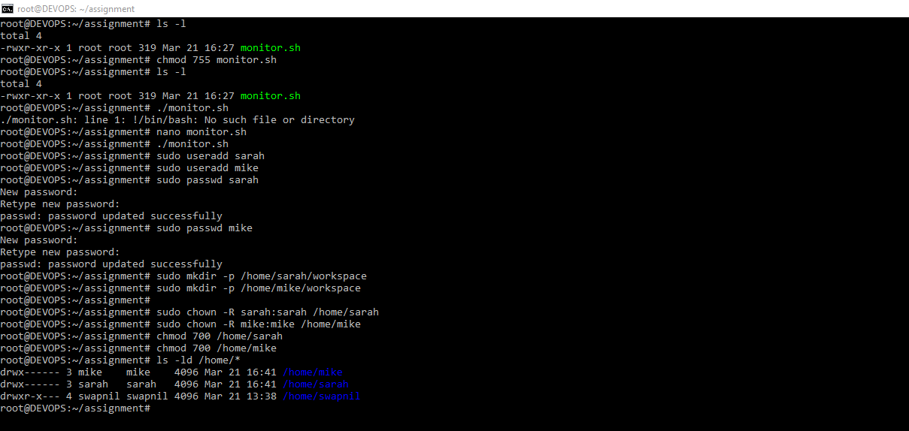
- Password Policy
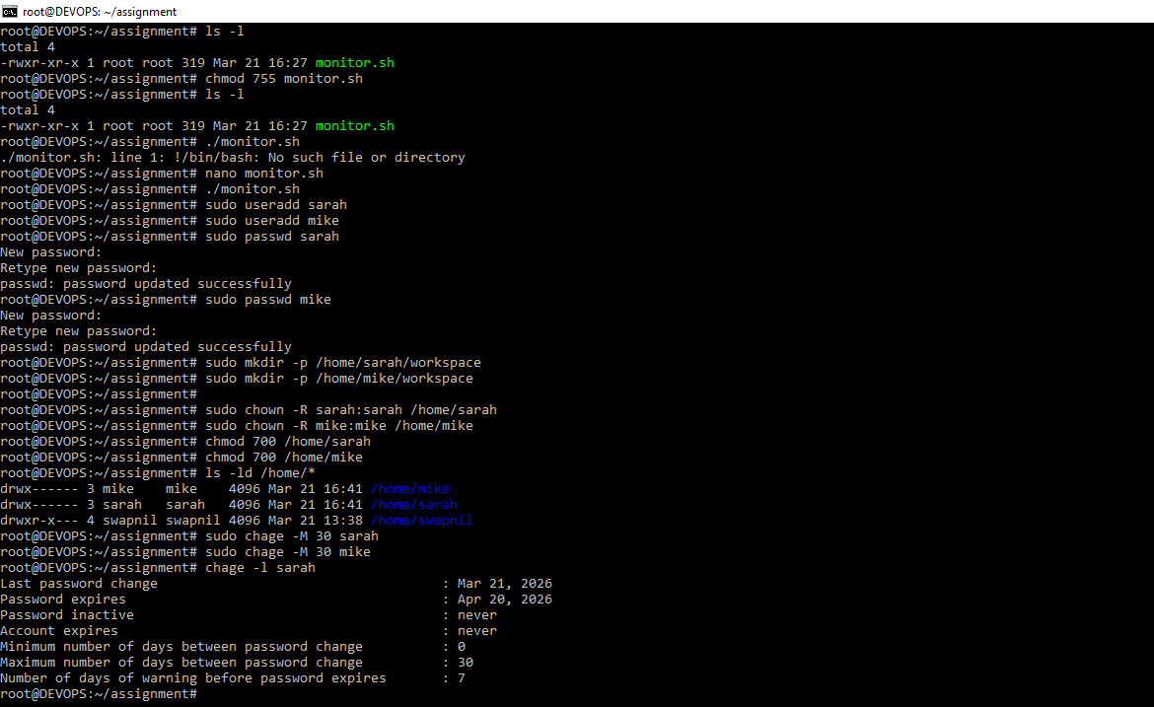
- Backup Scripts
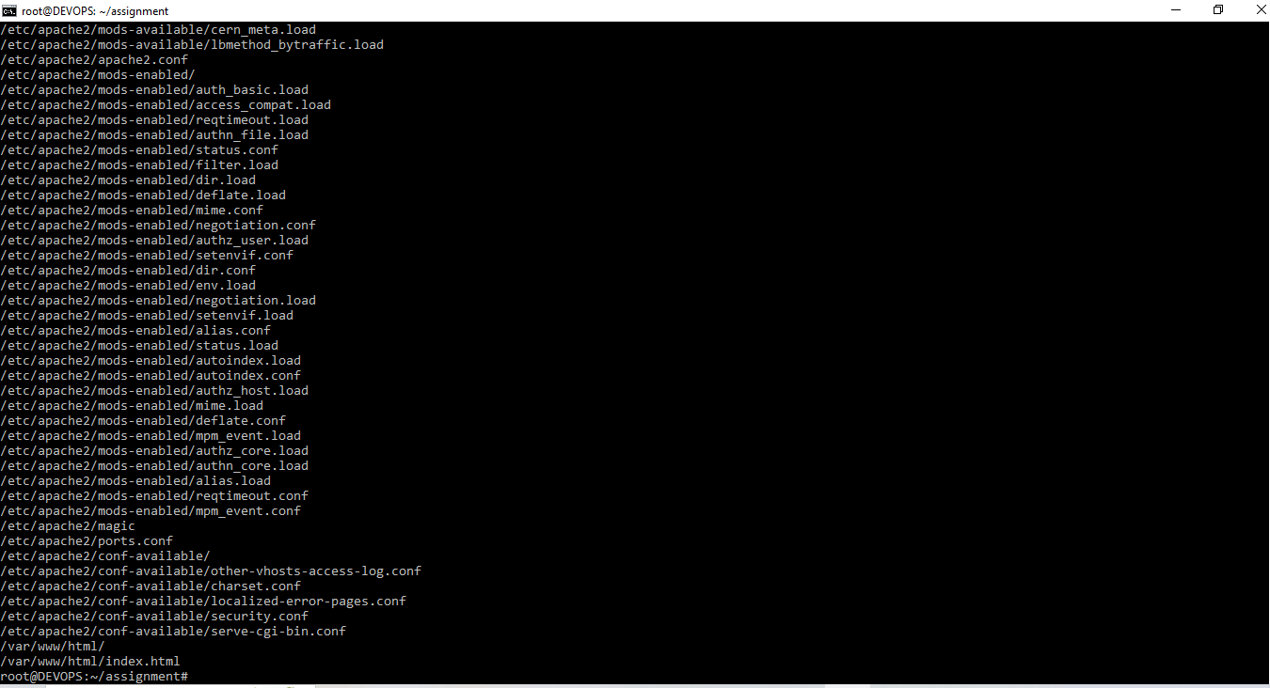
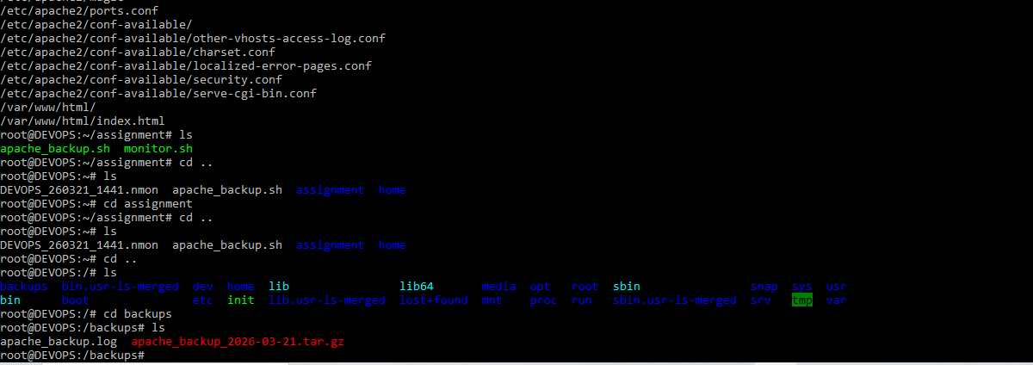
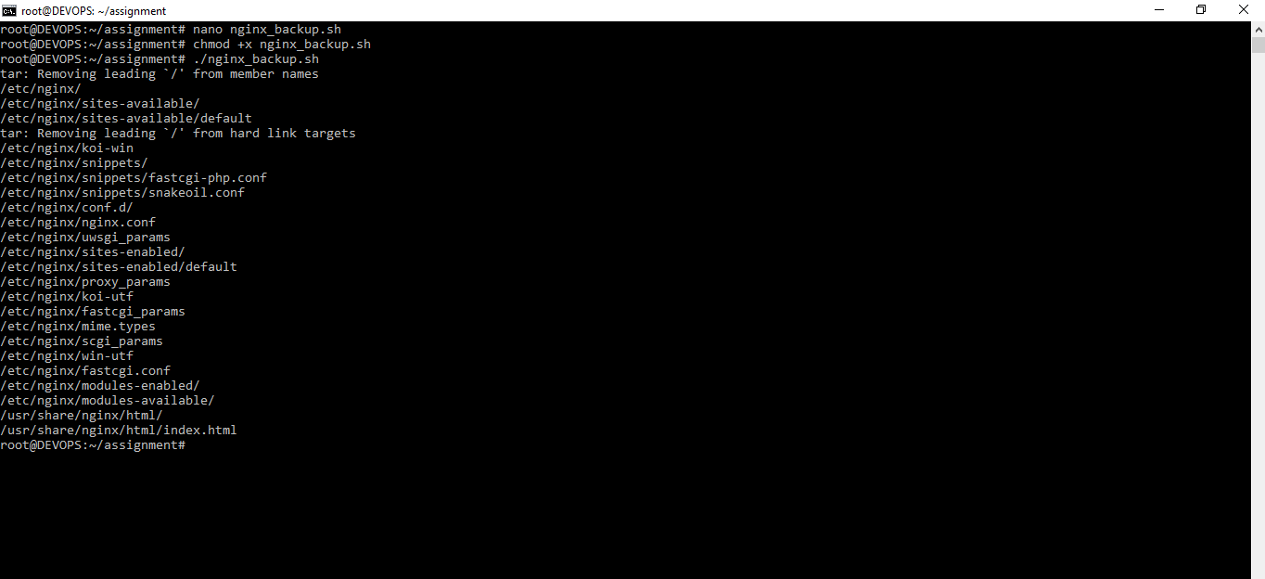
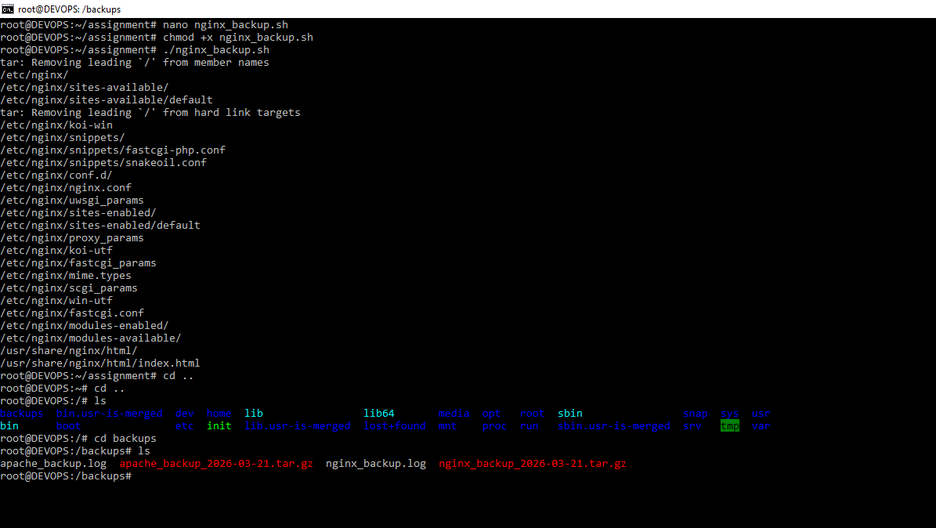
- Cron Job
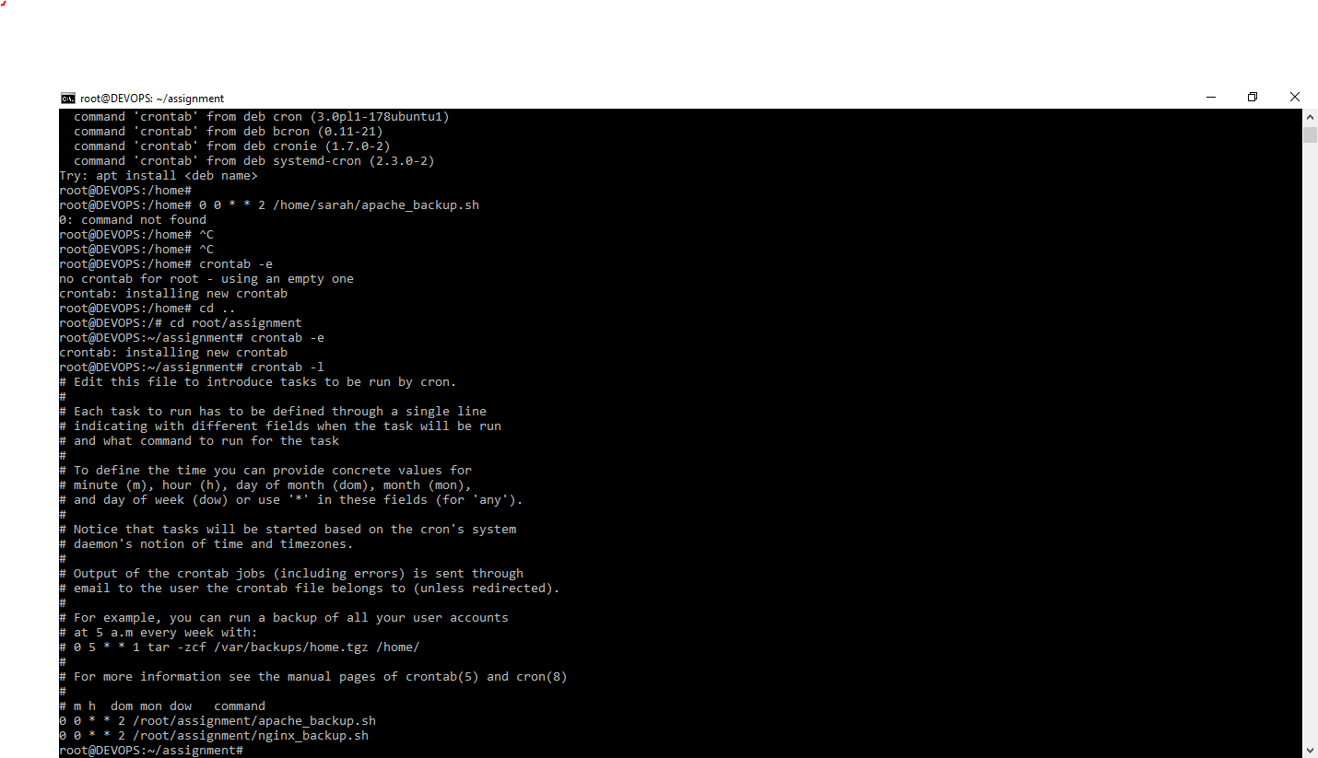

GitHub Repository
https://github.com/Dipakdave/testing-linux-and-server.gits

